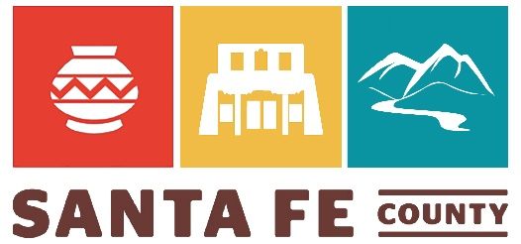

Tesuque Community Planning Committee

Summary of Meeting

December 13, 2021

WebEx

Welcome and Review Agenda: Community members were welcomed to the Tesuque Planning meeting to review comments submitted and the action steps culled out of the 2013 and from the 2022 plan.

Review highlighted comments in comprehensive comment matrix: Planning members went through the comments organized and submitted so far. There were highlighted questions from staff which were addressed and comments about specific comments.

Tesuque Community Vision Submitted by Lynn Pickard:
The Tesuque Village seeks sustainable growth that protects our natural and historic resources, while preserving our values, qualities, and culture. Tesuque seeks to retain its status as a traditional historic community by maintaining its character as a small, quiet, rural, agricultural-looking village with a diversity of people and incomes that is primarily residential but also fosters small-scale businesses and other businesses in appropriate places, all the while recognizing that it occupies the ancestral lands of the people of the Pueblo of Tesuque.

Review of Actions for implementation template:

Next Steps

- 2022 Draft Plan Review
- January 24, 2022 Committee Meeting
- Final Comments

Homework:
- Add if needed any additional elements to vision statement submitted by Lynn Pickard or your own version or elements to add.
- Peter Wurzburger will develop information about building on slopes
- Additional comments to be submitted to Planning staff by January 7
Examples of other Community Vision Statements:

Chimayó Vision Statement In the year 2038 Chimayó is made up of families and individuals who know their neighbors and care for each other. The ancient acequia system is still operating, maintained and cared for by local people who live next to it or use the water for irrigating. A central market and community center provides a place for farmers to sell or barter their produce and for artists to sell their work. Chimayó residents can buy groceries, see a nurse, do their laundry, and visit the post office in their community. Children and seniors are cared for and nurtured by education and health oriented facilities that sometime overlap. Chimayó fosters and supports learning opportunities; Chimayó children are cared for after school. Crime and drug use are low. Historical structures are in good repair and reflect the style and practices of their day. Historic placitas, national landmarks and neighborhoods are recognized and preserved. Orchards are pruned, farmland planted, bosque cleared of invasive species. The arroyos are free of trash to respect the natural beauty and spiritual soul of Chimayó. There is good water for everyone, and effective solutions for solid waste management. Chimayó is a safe place to live and walk. We have excellent fire protection and well-maintained roads. The infrastructure is evolving and well maintained. Through community events, children learn to respect their environment and understand the history of their home. The residents and landowners of Chimayó value the valley’s rural life style. We seek to preserve our unique environment for future generations, while at the same time respecting the right of the individual. We value our sense of community, honor our history and heritage of the community, respect diversity and desire to have a low impact on the environment and cultural resources. We identify with the peacefulness and tranquility of our open spaces. We enjoy the opportunities for solitude, prayer and pilgrimage. Chimayósos continue to have a strong voice in what happens in the community. Declaración de la Visión.

